**C. Deliverables / Output**

Submit the following in a Word or PDF file:

1. Screenshot of your AWS Console home page

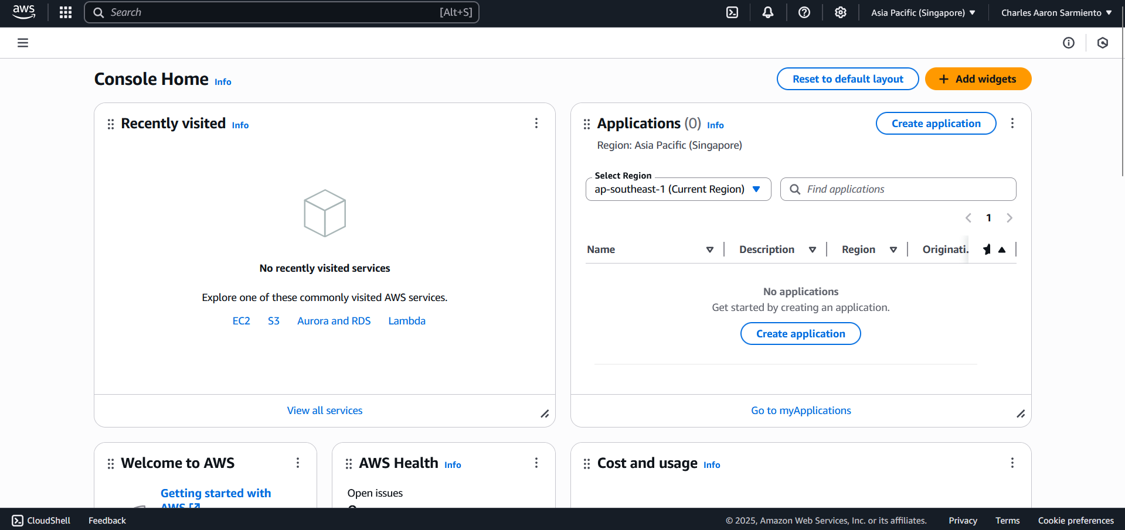

1. Descriptions of each service (EC2, S3, IAM):
   * What is the service for?
   * What can you do with it?

**Elastic Cloud Compute (EC2)**

* Provides resizable compute capacity in the cloud. With EC2, you can run applications, manage workloads, and scale infrastructure on demand in virtual computers / instances.

**Simple Storage Service (S3)**

* A cloud-based object storage service, allowing users to store and retrieve any amount of data. Common use cases of S3 include storage of files, images, or videos used in web applications.

**Lambda**

* A serverless, event-driven compute service. Unlike EC2, developers running their applications on Lambda do not have to worry about provisioning or managing servers. Common usage for Lambda includes modern web application frameworks like NextJS, that allows for deployment via serverless functions.

**Identity Access Management (IAM)**

* A service that enables you to securely control access to AWS resources. It allows users to manage who can access (authentication), as well as what actions they can do (authorization). This is used commonly in organizations with multiple people managing the AWS resources.

1. Screenshot of your Billing Dashboard (showing Free Tier status or no charges)

